**Office Essentials**

**ITC 2060**

**UNCP**

**Summer 1**

**Instructor: Dr. Cynthia Xin Zhang**

**Student: Brandon Watts**

**Table Of Contents**

|  |  |
| --- | --- |
| **1. Project Overview** | **3** |
| **2.Scope and objectives** | **3** |
| 2.1 Application window with Menu Bar | **3** |
| 2.2 File Menu | **3** |
| 2.3 General Application Menu | **3** |
| 2.4 Game Application Menu | **3** |
| 2.5 Help Menu | **3** |
| **3 File Menu** | **4** |
| 3.1 New File | **4** |
| 3.2 Open File | **4** |
| 3.3 Save | **4** |
| 3.4 Save As | **4** |
| 3.5 Exit | **4** |
| **4 General Application Menu** | **4** |
| 4.1 Loan Calculator | **4** |
| 4.2 Text Editor | **4** |
| **5 Game Application** | **5** |
| 5.1 Puzzle Game | **5** |
| 5.2 Tic Tac Toe | **5** |
| **6 Help Menu** | **5** |
| 6.1 Update Client | **5** |
| 6.2 Report A Bug | **5** |
| 6.3 About | **5** |
| **7 GUI** | **6** |
| 7.1 Application Window | **6** |
| 7.2 New File | **6** |
| 7.3 Open File | **7** |
| 7.4 Save As | **7** |
| 7.5 Loan Calculator | **8** |
| 7.6 Text Editor | **8** |
| 7.7 Puzzle | **9** |
| 7.8 Tic Tac Toe | **9** |
| 7.9 Update Client | **10** |
| 7.10 Bug Reporter | **10** |
| 7.11 About | **11** |
| **8 Conclusion** | **11** |

**1. Project Overview**

Office Essentials is a JavaFX program that allows a user to edit, create, save, and open text (.txt) files. The program also provides a loan calculator as well as a few games to keep you entertained.

**2. Scope and Objectives**

The program was created with JavaFX, which requires java 8, and a compiler to run the program. The application can be setup on machines with access to the above pre-requites.

2.1 Application window with Menu Bar

Provides a new application window with a Menu Bar and Menus “File”, “General Application”, “Game Application”, and “Help”

2.2 File Menu

Allows use of the file menu which contains “New File”, “Open File”, “Save”, “Save As”, and “Exit”.

2.3 General Application Menu

Allows use of the General Application menu which contains a “Loan Calculator”, and a “Text Editor”

2.4 Game Application Menu

Allows use of the Game Application menu which contains a “Puzzle Game”, and “Tic Tac Toe”.

2.5 Help Menu

Allows use of the Help menu which will contain a update client, a bug reporting system, and an about window.

3. File Menu

Allows use of the file menu which contains “New File”, “Open File”, “Save”, “Save As”, and “Exit”.

3.1 New File

Allows the user to create a new text file

3.2 Open File

Allows the user to open an existing text file

3.3 Save

Allow the user to save the text file

3.4 Save As

Allows the user to save the text file with a different name

3.5 Exit

Allows the user to exit the program.

4. General Application Menu

Allows use of the General Application menu which contains a “Loan Calculator”, and a “Text Editor”

4.1 Loan Calculator

Gives access to a Loan Calculator

4.2 Text Editor

Gives access to an in-application text editor

5. Game Application Menu

Allows use of the Game Application menu which contains a “Puzzle Game”, and “Tic Tac Toe”.

5.1 Puzzle Game

Gives access to a puzzle game click to drag pieces to form a complete picture

5.2 Tic Tac Toe

Gives access to a game of tic tac toe, first one to get three in a row wins.

6. Help Menu

Allows use of the Help menu which will contain an update client, a bug reporting system, and an about window.

6.1 Update Client

Currently just an animation but can be used in the future to update the application over the internet.

6.2 Bug Reporting System

Current just display information to contact the creator but in the future can be used to actually send emails.

6.3 About

Displays a text field that explains a little info about the application.

7. GUI

7.1 Application Window

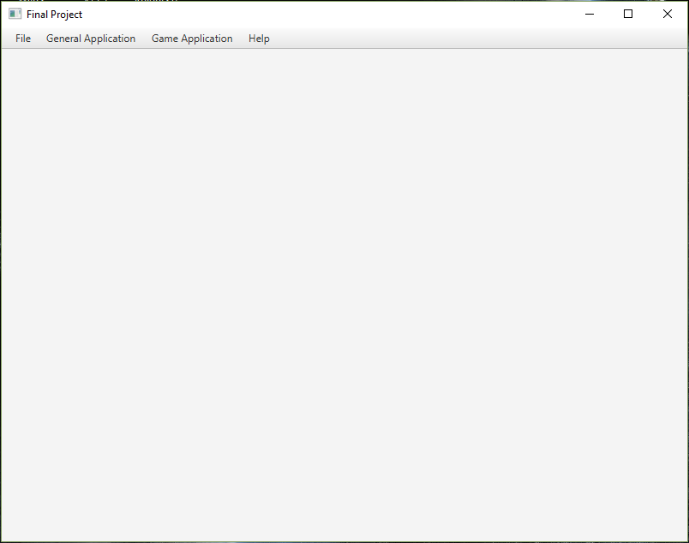

7.2 New File

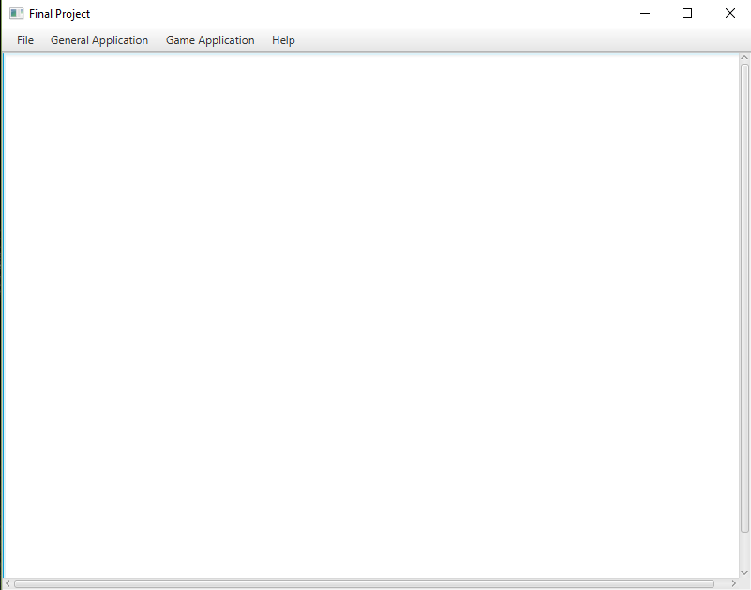

7.3 Open File

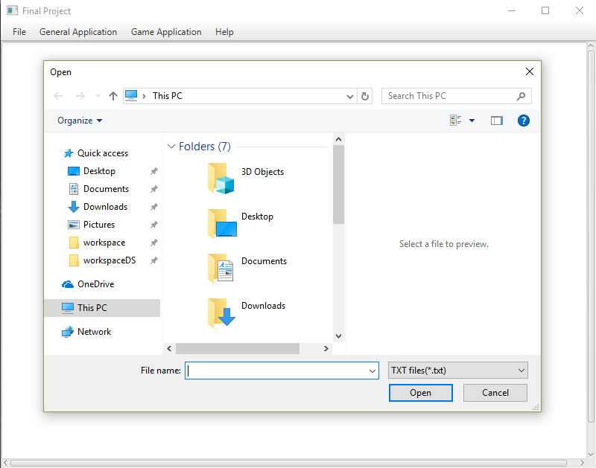

7.4 Save As

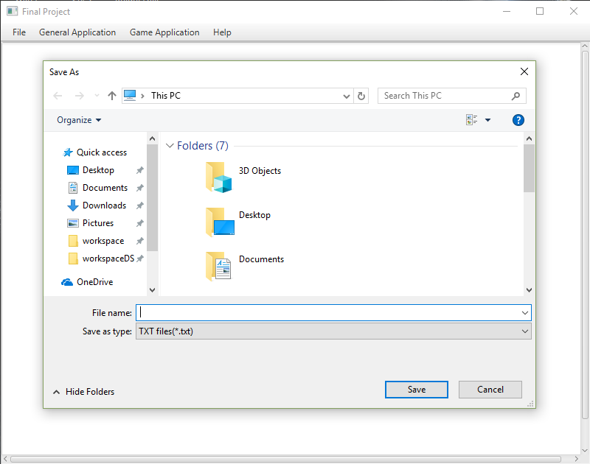

7.5 Loan Calculator

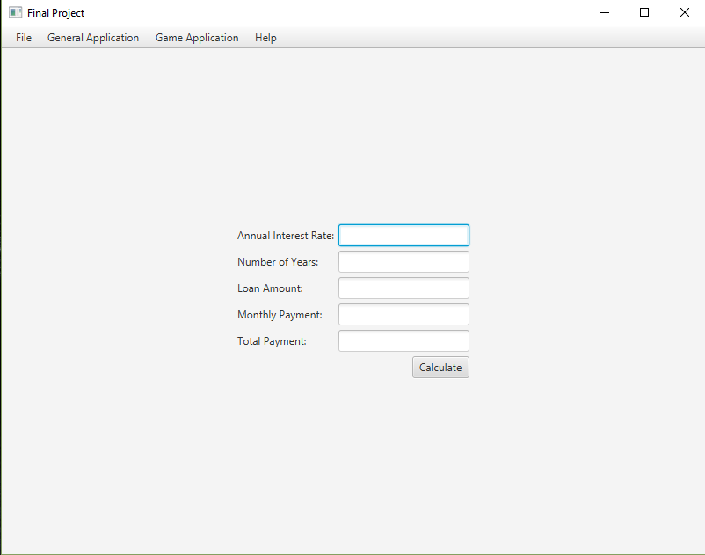

7.6 Text Editor

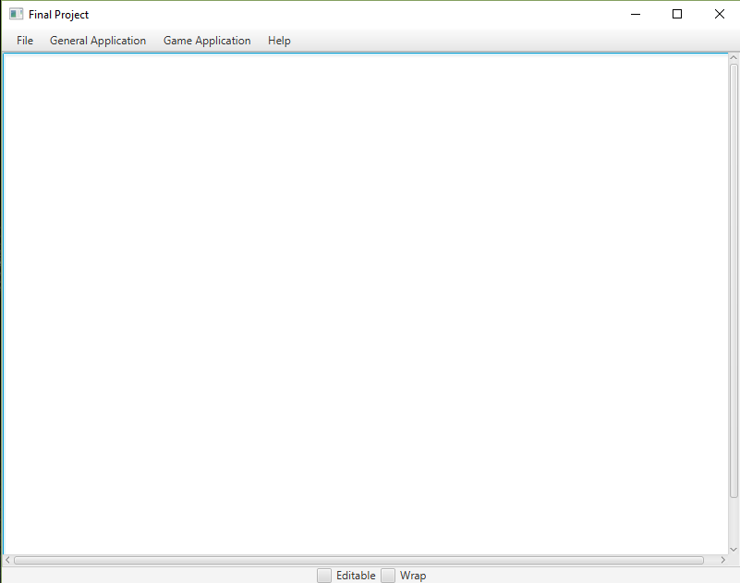

7.7 Puzzle Game

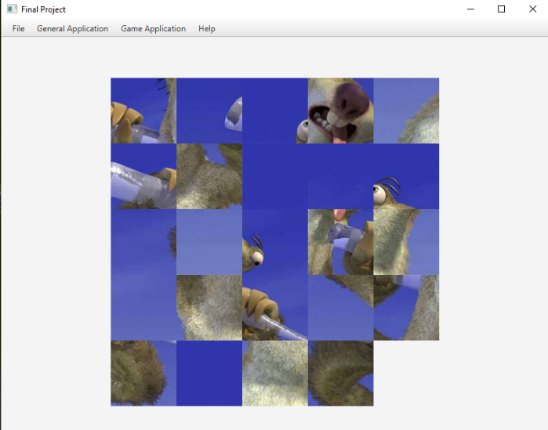

7.8 Tic Tac Toe

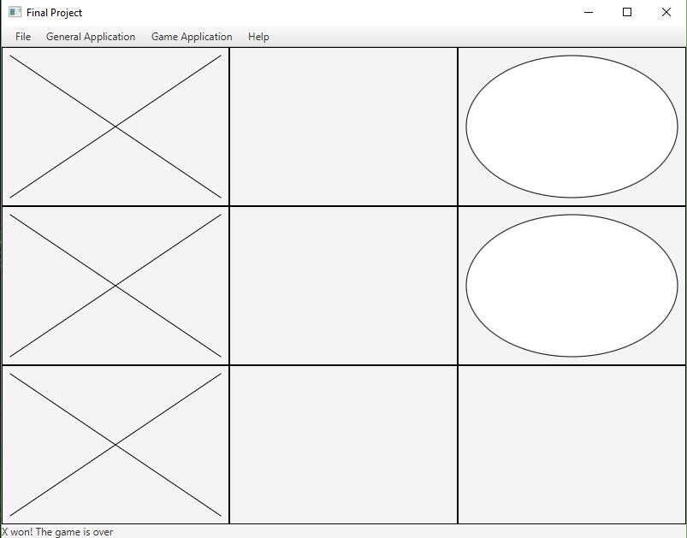

7.9 Update Client

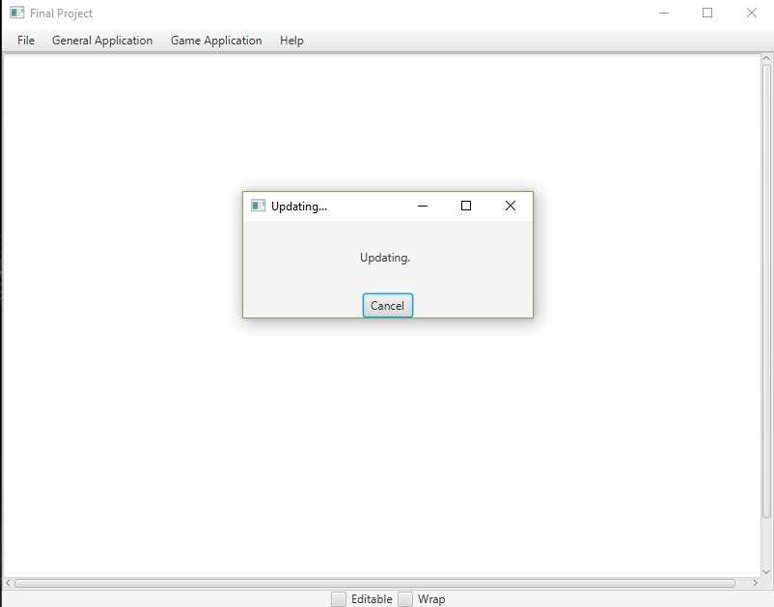

7.10 Report a Bug

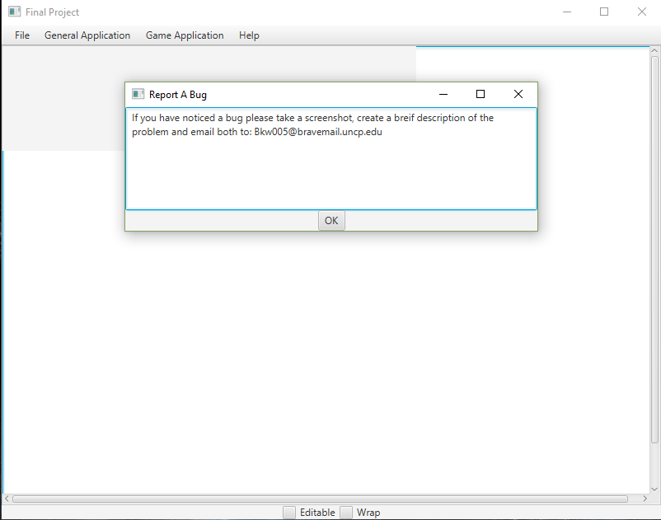

7.11 About

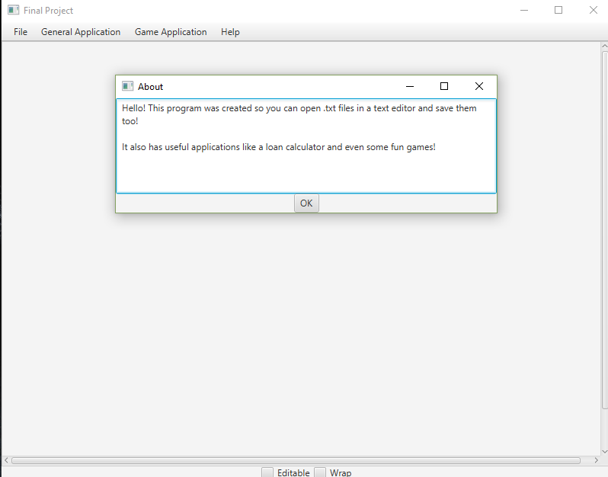

8. Conclusion

The Office Essentials program is the bare minimum piece of software you can use to key notes and calculate loans. The user will be able to create, open, edit, and save .txt documents. Future additions to this program could include:

* User authentication which allows you to know who saved or edited the files
* Saving numbers from your loan calculator
* Adding a standard calculator
* Finishing the update client
* And many more addtions…